**RENEWABLE_ENERGY.CSV**

import plotly.express as px

import pandas as pd

df=pd.read_csv('Renewable_Energy.csv')

print(df)

fig = px.line(df, x='Country', y='Monthly_Usage_kWh', title='Usage Record')

fig.show()

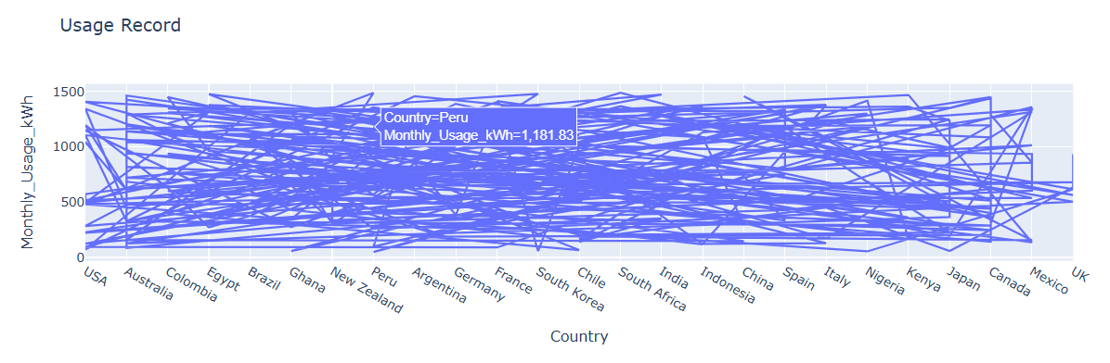

import plotly.express as px

import pandas as pd

df=pd.read_csv('Renewable_Energy.csv')

print(df)

fig = px.bar(df,x='Region', y='Cost_Savings_USD', title='Adoption record')

fig.show()

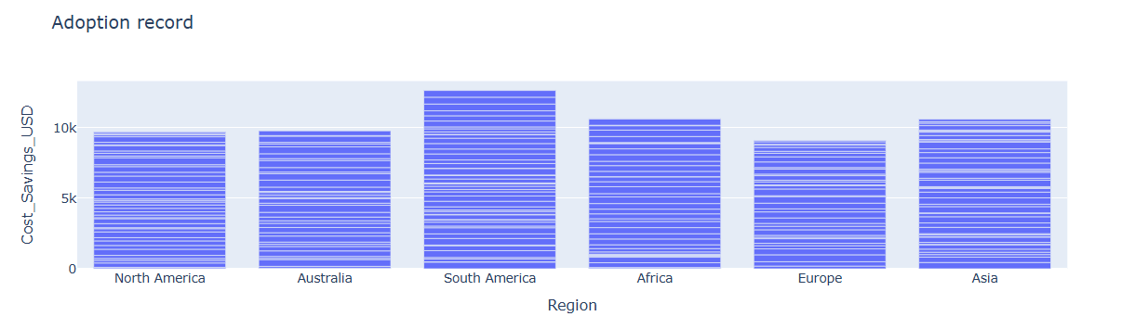

import plotly.express as px

import pandas as pd

df=pd.read_csv('Renewable_Energy.csv')

print(df)

fig=px.pie(df,values='Cost_Savings_USD',names='Adoption_Year')

fig.show()

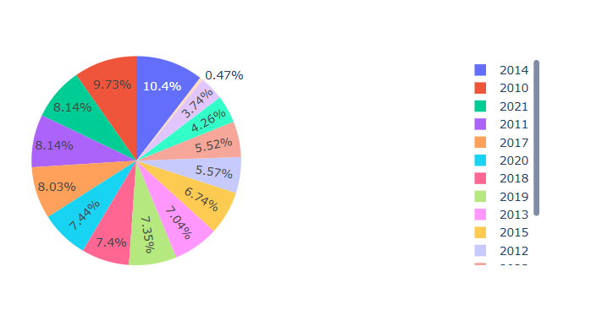

import plotly.express as px

import pandas as pd

df=pd.read_csv('Renewable_Energy.csv')

print(df)

fig=px.scatter(df,x='Region',y='Adoption_Year')

fig.show()

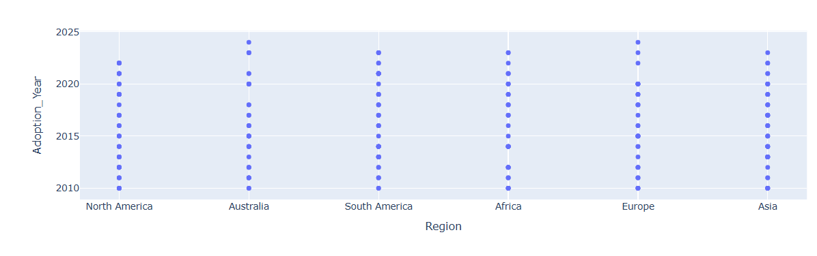

import plotly.express as px

import matplotlib.pyplot as plt

import pandas as pd

df=pd.read_csv('Renewable_Energy.csv')

print(df)

plt.hist(df['Adoption_Year'], bins=[2012,2014,2016,2018,2020,2022,2024])

plt.show()

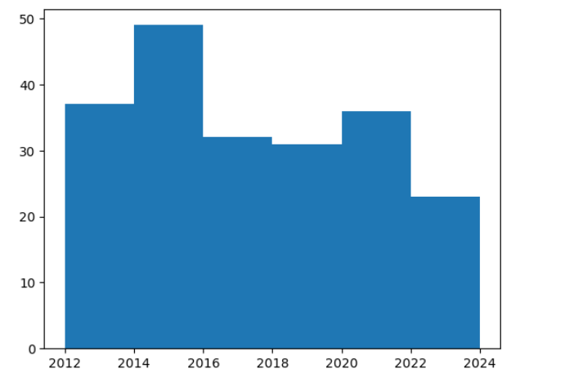

import seaborn as sb

import pandas as pd

import matplotlib.pyplot as plt

df=pd.read_csv('Renewable_Energy.csv')

print(df)

plt.xticks(rotation=90)

sb.lineplot(x='Region',y='Monthly_Usage_kWh',data=df)

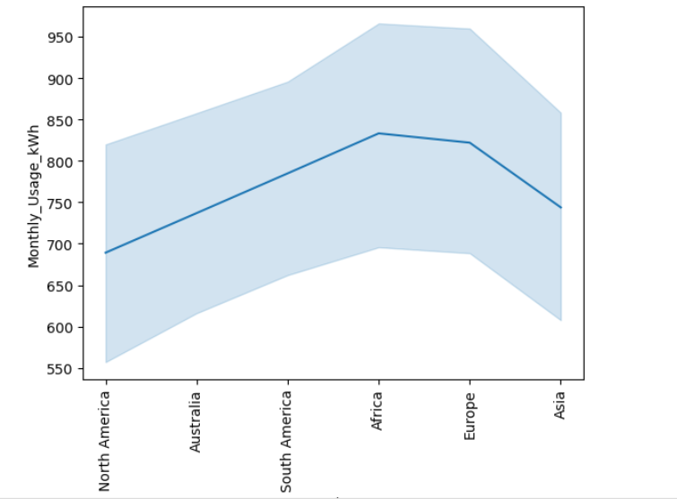

import seaborn as sb

import pandas as pd

import matplotlib.pyplot as plt

df=pd.read_csv('Renewable_Energy.csv')

print(df)

sb.relplot(x='Country',y='Adoption_Year',data=df)

plt.xticks(rotation=90)

plt.show()

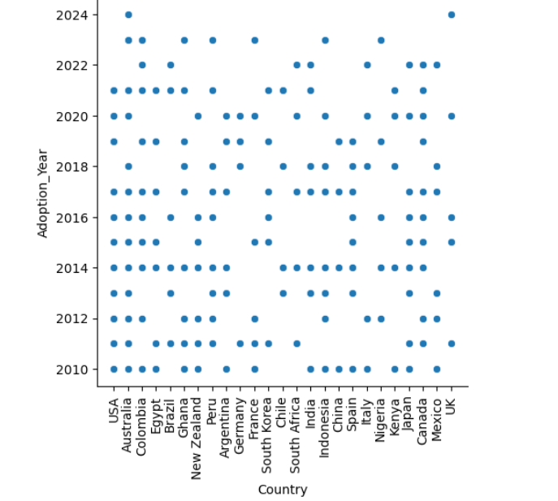

import seaborn as sb

import pandas as pd

import matplotlib.pyplot as plt

df=pd.read_csv('Renewable_Energy.csv')

print(df)

sb.barplot(x='Energy_Source',y='Monthly_Usage_kWh',data=df)

plt.xticks(rotation=90)

plt.show()

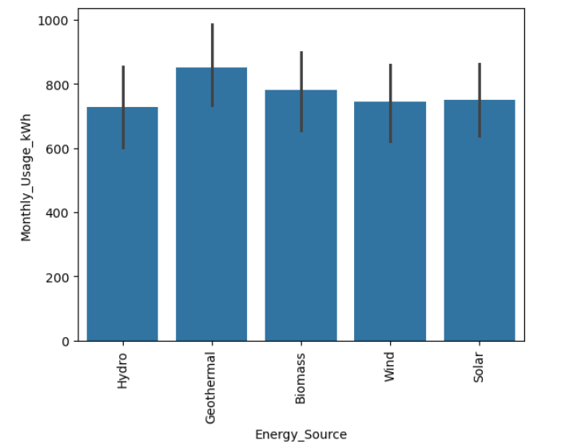

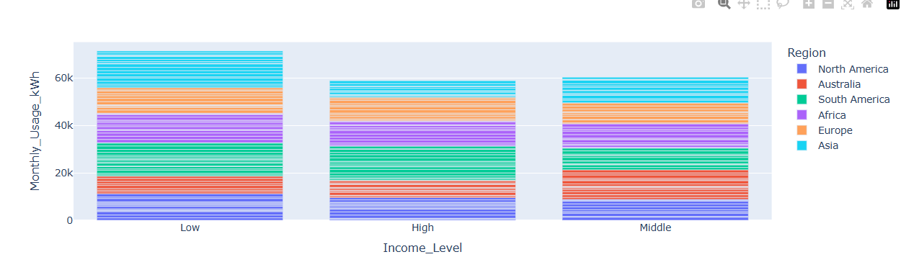

import pandas as pd

import plotly.express as px

df=pd.read_csv('Renewable_Energy.csv')

print(df)

fig=px.scatter(df,x='Cost_Savings_USD',y='Monthly_Usage_kWh',color='Country')

fig.show()

